Conveniently Located in the Heart of North Waterloo
Renaissance School of the Arts is located at 168 Lexington Court (Unit F), Waterloo, Ontario, Canada. We are easily accessible by car from most of the surrounding region, via Highway 85.
If you are travelling by city bus, Grand River Transit route 31 runs neatly down Lexington Road, with a bus stop right in front of our building. Routes 12 and 7C are a short walk from the studio.
In addition to serving residents of the city of Waterloo, several of our students come from areas such as Cambridge, Guelph, Elmira, Linwood, New Hamburg and Wellesley - even as far away as London, Ontario.
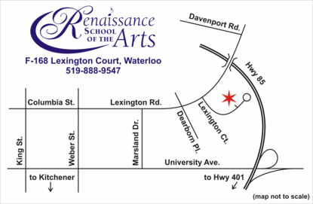
Click here for a full-size printable map image.
Or, click here for a map.

<div id="main_content">
<div id="main_content_padding">
<h2>Conveniently Located in the Heart of North Waterloo</h2>
<p>Renaissance School of the Arts is located at 168 Lexington Court (Unit F), Waterloo, Ontario, Canada. We are easily accessible by car from most of the surrounding region, via Highway 85.</p>
<p>If you are travelling by city bus, Grand River Transit route 31 runs neatly down Lexington Road, with a bus stop right in front of our building. Routes 12 and 7C are a short walk from the studio.<br /><br /> In addition to serving residents of the city of Waterloo, several of our students come from areas such as Cambridge, Guelph, Elmira, Linwood, New Hamburg and Wellesley - even as far away as London, Ontario.</p>
<p style="text-align: center;"><img src="/files/33_Map_2007_415x271.gif" alt="" /></p>
<p><br /> Click <a href="/files/34_Map_2007.gif">here</a> for a full-size printable map image.<br /> Or, click <a href="http://www.google.ca/maps?hl=en&amp;q=Renaissance+School+of+the+Arts,+Waterloo&amp;z=3">here</a> for a <img style="vertical-align: middle;" src="/files/35_google.gif" alt="" /> map.</p>
</div>
</div>

